|  |
| --- |
|  |
| Finding Dawn |
| If you move, you survive |
| Version 0.1  All work Copyright © 2018 by Silly Arts Games.  All rights reserved. |
| **Harshil Mehta**  **Pragnesh Patel**  **Dylan Schmidt-Cunningham** |
|  |

|  |
| --- |
| Feb 02nd 2018 |

**Table Of Contents**

***Version History*** 3

***Game Overview*** 4

***Game Play Mechanics*** 4

***Camera*** 4

***Controls*** 4

Saving and Loading 5

Interface Sketch 5

Menu and Screen Descriptions 5

Game World 6

Levels 6

Characters 6

Non-player Characters 6

Enemies 6

Weapons 6

Items 6

# Version History

Github Repository : https://github.com/harshilme2/Game-Project

**Version 0.1**: Feb 2, 2018

Project Setup

Total Commits - 1

# Game Overview

*It been long time since player has seen the day light. Fear of scary dungeon kept the player trapped for long time. The place has become hard to survive and it’s time for player to move out for his survival. The goal of this game is to find your way out of dungeon.*

# Game Play Mechanics

* *Moving in left-right-up-down*
* *Use weapon to kill the opponent*
* *Kill enemies by shooting/knife*
* *Find your way out through dungeon*
* *Collect weapons on the way so use against strong enemy*

# Camera

*This game has Top-Down camera view.*

# Controls

*This game will use arrow keys and Space bar*

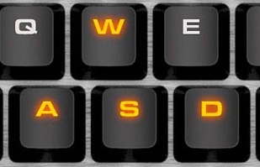

# Saving and Loading

*The game will have checkpoints. If the player dies, it will utilise the life and start from last check point.*

# Interface Sketch

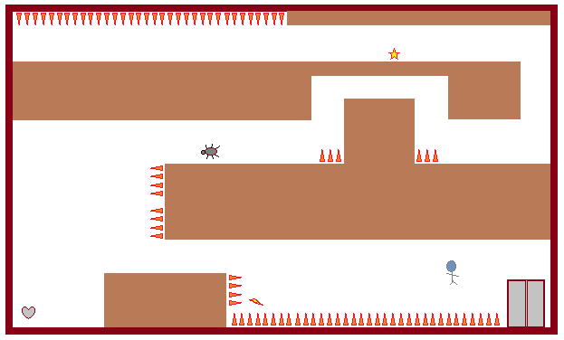

# Menu and Screen Descriptions

*There will be timer and health given for player. Player enters from one end and exits on other end finding his way out. There will be time shown in blue color and health in red as shown in fig 7.1*



**Fig 7.1**

# Game World

*It’s a dungeon world.*

# Levels

*There will be three level.*

# Characters

*Characters will be a human. Enemies will be bugs and other creatures.*

# Non-player Characters

Enemies like bugs and creatures.

# Enemies

*Bugs and scary creatures*

# Weapons

*Knife, sword*

# Items

*Spikes, Collectables like heart for health, Energy for timer.*